 | BAHRIA UNIVERSITY, (Karachi Campus)  Department of Software Engineering  Assignment 2 – Spring 2022

COURSE TITLE: Web Engineering
COURSE CODE: SEN 310
Class: BSE-6 Shift: Morning
Course Instructor: Deadline: 29-Apr-22
Date: 11-Apr-2022 Max. Marks: 4.5 Marks

KINZA NOOR 65141

Question No. 1 [CLO3: 4.5 Marks]
Using the knowledge gained by learning and implementing HTML5, CSS, Boostrap, Flexbox and Javascript Basics. The color themes and good concepts should be visible on your website and fully responsive. Submission must includes the following:
- Html5 Script
- CSS/Flexbox Script
- Javascript
- Boostrap
- Zip files for all the Scripts
- Screenshot of your website
SCREENSHOTS OF WEBSITE
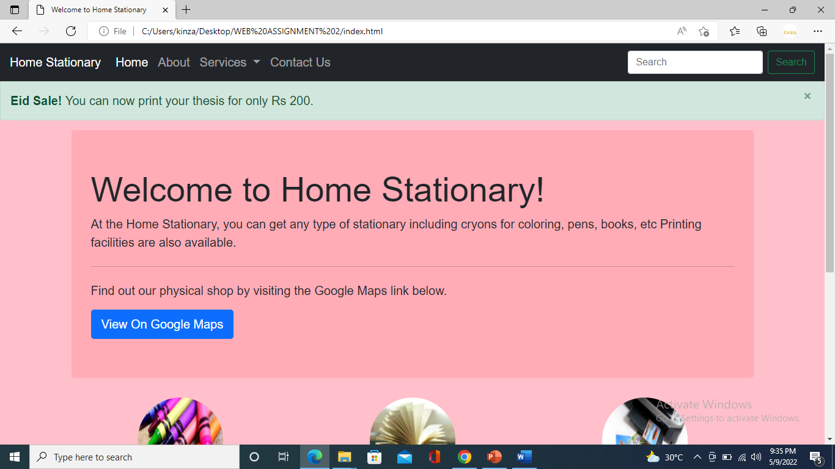

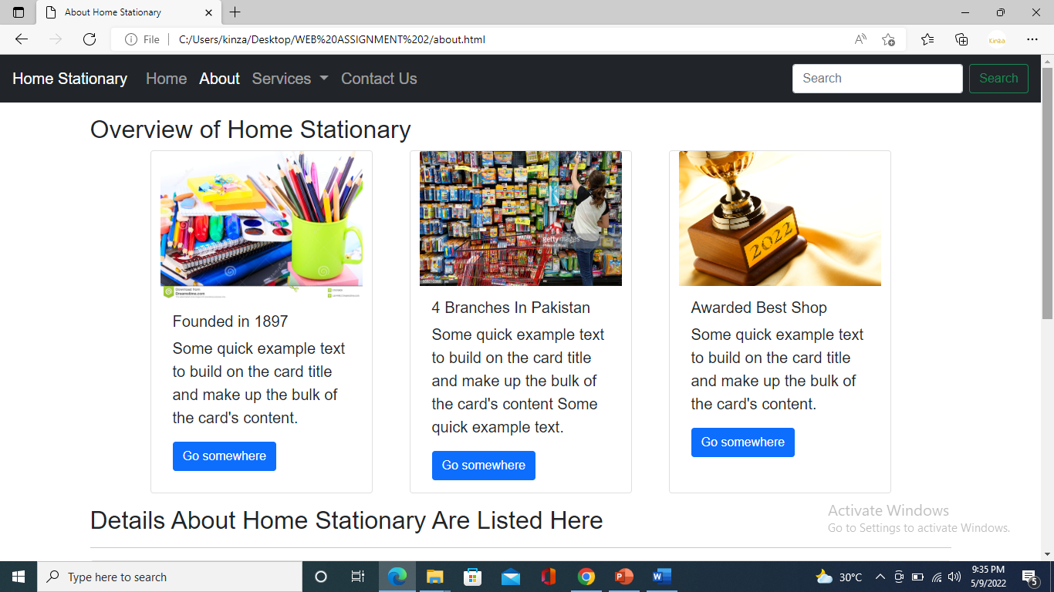

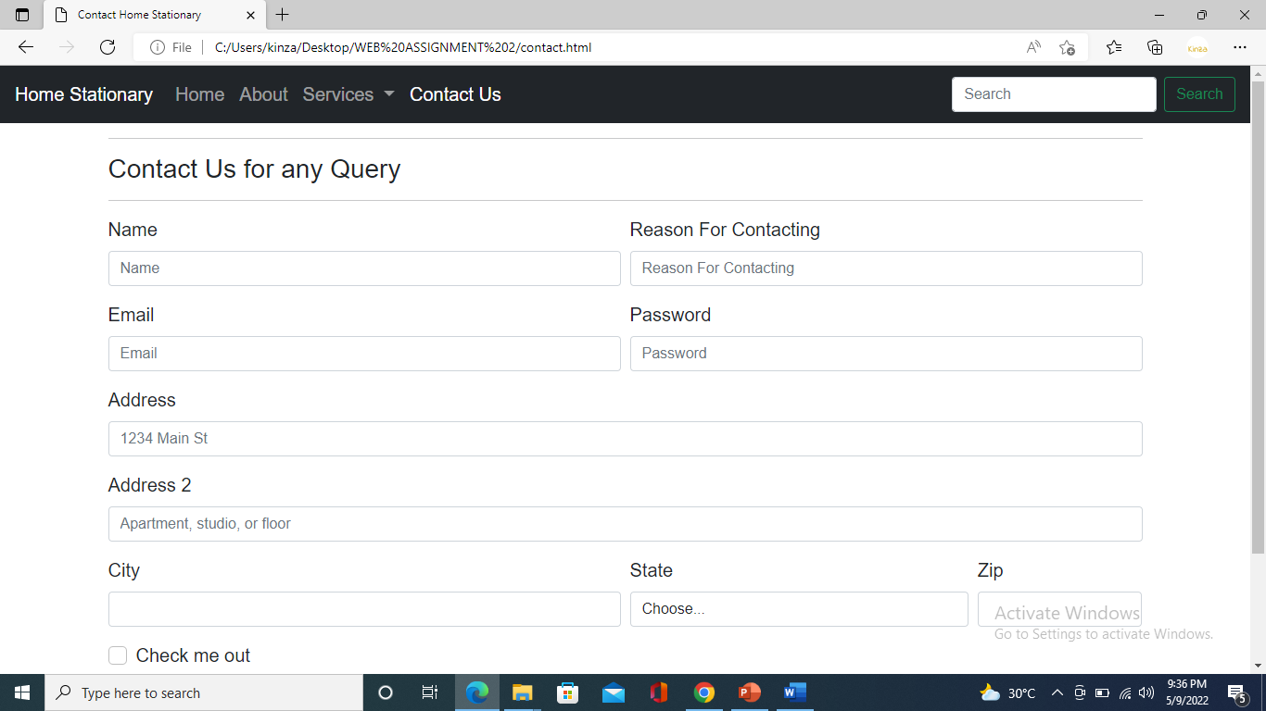

RESPONSIVENESS:

